Scoil Phádraig Biodiversity Trail
How many bird tables are there in total?
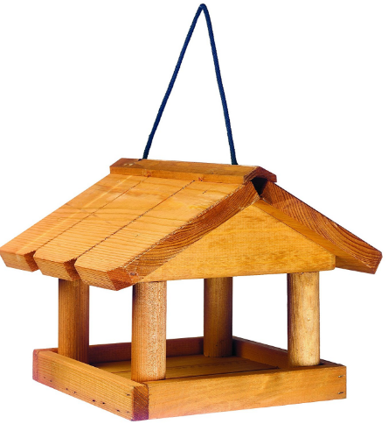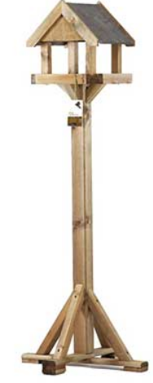
How many bird nesting boxes can you find?
These have small round holes!
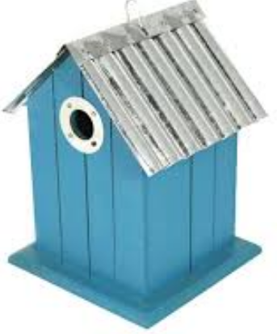
How many bird feeders can be found?
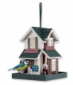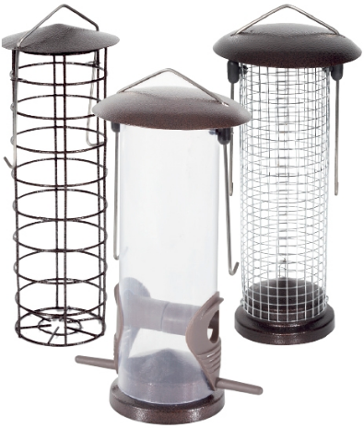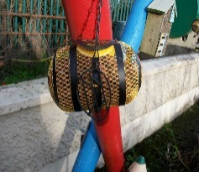
How many bat boxes are there?
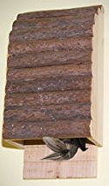
How many hedgehog homes are there?
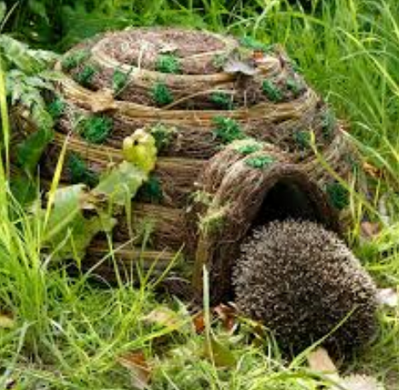
How many small insect hotels are there in total?
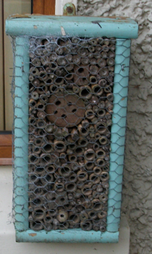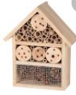
How many squirrel shelters can be found?
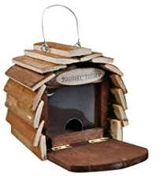
How many recycled tyre planters can be found?

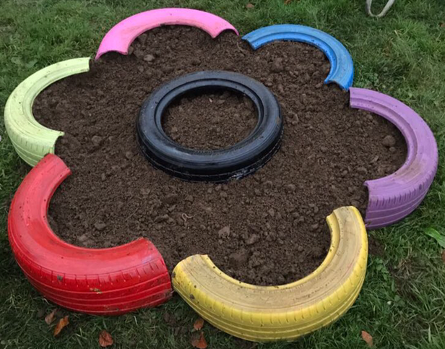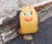

What colour is the watering can beside our log pile?
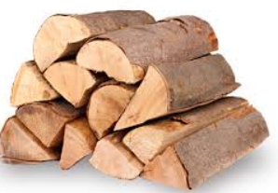
What colour is our large water butt?
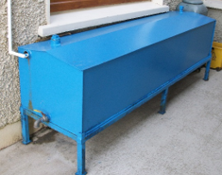
What colour is our outdoor compost bin?
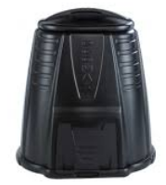
What colour is the largest bucket pond in the garden?
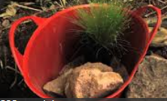
Name three items that we collect in the compost bin?
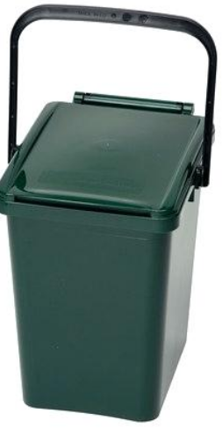
- 2. 3.
Name three flowers that grow in our
wild flower bed in the garden?
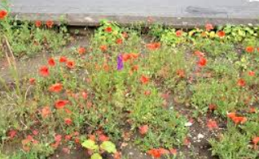
- 2. 3.
Name three living things that may be found near a log pile?
- 2. 3.
Name three Irish mammals that may be found in a hedgerow?
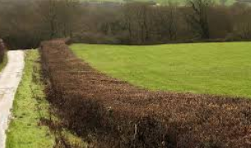
- 2. 3.
Name three species of trees that grow on our school grounds? 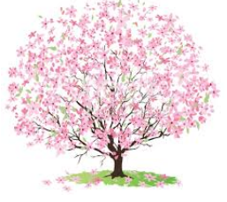 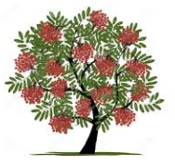
- 2. 3.

