Scoil Phádraig
Corduff
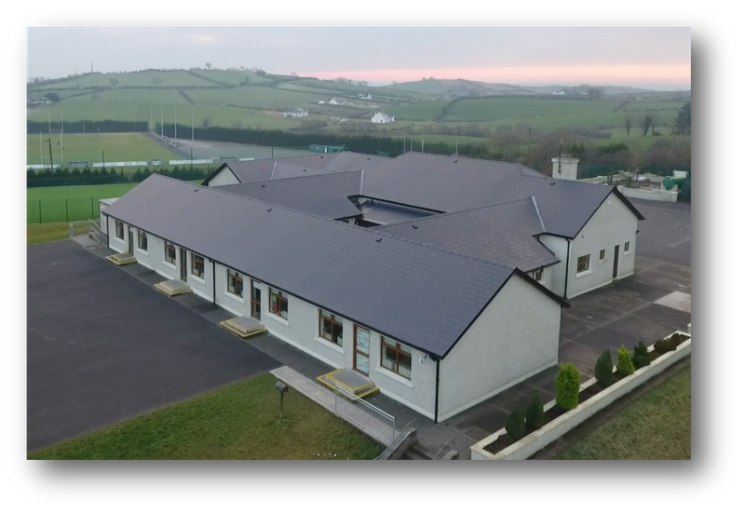

Booklet for Parents of Infants Starting School

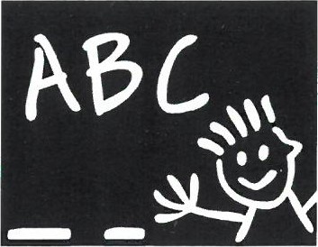

Introduction

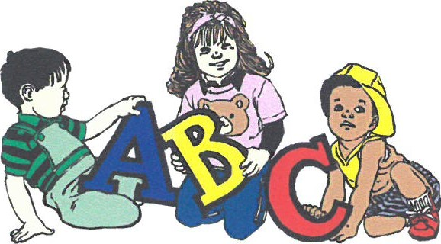

Starting school is the first big change in the life of your child. Up to this he/she has felt safe and secure with you in the home and family but now he/she is facing the wider world of classroom and school. This may seem a big step for someone so small, but most children manage it without any great fuss or stress - and in fact take to it like ducks to water.
However, it is also a time when parents and teachers should take special care to ensure that the transition from home to school is as smooth as possible. If the child's first experience of school is one of happy involvement, a very good foundation will have been laid for fruitful school years ahead.
It is important too, particularly during the first year that parents understand what the aims of the school are, as many may be expecting too much in the way of academic achievement.
We know from experience that parents are very anxious to help in any way possible. We have, therefore, included some ideas for the home, which should stimulate the child's interest and nurture his/her desire to know more.
With these aims in mind we have put together this little booklet as a general guide for parents. It deals briefly with the period before your child comes to school and his/her introduction to Junior Infants. We trust you will find it helpful and that your child will be happy and fulfilled with us.

Getting Ready for Learning

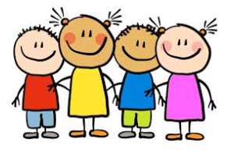
Children are natural learners. They have an inbuilt curiosity and an eagerness to know more about everything about themselves, about others and about the world around them. And they learn fast- but only when they are ready, and their interest is aroused.
Because they come to us so young we must guard against putting pressure on them to learn what they are not yet ready for. Demanding too much too soon can switch a child off completely. At the same time, we must cultivate readiness so that they can get moving as soon as possible.
The rates of progress of children can vary greatly. We try to give them an opportunity to move ahead at their own pace or as near to it as possible.
Our first year in school therefore, is mainly about settling in, relating to others, making friends, feeling happy and gradually getting used to the routine of the school. On the learning side the emphasis is on getting children ready for learning by -
- Developing their oral language and expression.
- Sharpening their senses, especially seeing, hearing and touching.
- Developing physical co-ordination especially of hand and fingers.
- Extending their concentration span and getting them to listen attentively.
- Learning through play — the most enjoyable and effective way.
- Co-operating with the teacher and other children.
- Performing tasks by themselves.
- Working with others and sharing with them.
- Teaching each child to accept the general order, which is necessary for the class to work well.

Life Skills - Before Your Child Starts School

You should ensure that he/she is as independent as possible - physically, emotionally and socially. If he/she can look after him/herself in these areas he/she will feel secure and confident and settle in readily.

It would help greatly if he/she is able to:
- Button and unbutton his/her coat and hang it up.
- Use the toilet without help and manages buttons. Also encourage personal hygiene and cleanliness. Your child should know to flush the toilet and wash his/her hands, without having to be told.
- Use his/her hanky/tissue when necessary.
- Share toys and playthings with others and "take turns". Tidy up and put away his/her playthings.
- Remain contentedly for a few hours in the home of a relation, friend or neighbour. If he/she had this experience, then separation from his/her parents when he/she starts school will not cause him/her any great anxiety.

In The Early Days
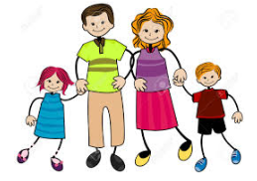
Your child's first day/week at school is a time to remember for the rest of his/her life. You can help to make it a happy one for him/her.
- Tell him/her about school beforehand, casually, and talk about it as a happy place where there will be a big welcome for him/her and he/she will meet new friends.
- Don't use school or the teacher as a threat. "If you behave like that for teacher she'll be very cross" though said light-heartedly can make some children very apprehensive.
- If you feel it would help, you could take him/her to the junior classroom and play area on an afternoon during June when the other children have gone home. He/she can browse around and become familiar with his/her new environment. He/she could meet his/her teacher, as well.
- He/she will like to have his/her new uniform and his/her new bag when he/she begins. These help him/her identify more readily with the school and other children.
- Your child's books will be given to them over the first few weeks, or until such time as they are needed. The teacher may also keep books or collect books. This minimises books getting lost. Please have your child warned of this fact; in case he/she thinks they will never see the books again. All books/copies will be marked with your child's name and readers will be covered.
- Your child will only feel important if he/she has something in his/her school bag, so perhaps you could buy a copy or colouring book for him/her, which he/she could use at home.

When you arrive at the school each morning, be as casual as you can. He/she will meet a teacher and the other children and will be shown to their seats.
Having assured him/her you will be back to collect him/her, wish him/her goodbye and make your qetawav without delay.

Handling the Upset Child

In spite of the best efforts of both teacher and parents a small number of children will still become upset. If your child happens to be, don't panic. Patience and perseverance can work wonders.

A Word of Advice

Trust the teacher and the staff. They are experienced and resourceful and are used to coping with all kinds of starting- off problems.
Try not to show any outward signs of your own distress. Sometimes the parents are more upset than the child and are the main cause of his/her anxiety.
When you have reassured your child, leave as fast as possible. The teacher can distract and humour him/her more easily when you are not around.
Check back discreetly in a short while. You will invariably find that calm has been restored.
You must be firm from the start. Even if a child is upset you must insist that he/she stay for a short time-even ten minutes. They must never feel that they are winning the psychological battle of wills.

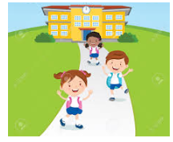
Going Home

Be sure to collect him/her on time. Children can become very upset if they feel they are forgotten.
Keep out of view until the children are brought to the front door.
If at any time the collecting routine must be changed ensure you tell the child and the teacher.

School Routines
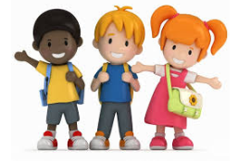
- School begins at 9.20a.m. To ease the child into the school routine we have a policy where Junior Infants go home for several days at 12 noon (no more than 2 weeks). After that they go home at 2:00p.m. Please make sure that your child is collected at 2:00p.m. as the teacher needs that hour between 2:00p.m. and 3:00p.m. to prepare for the next day. Get him/her into the habit of being in good time for school from the beginning.
- Midmorning break: 11:00am - 11.12am
- Lunch Break: 12:40-1pm
- Children need plenty of rest after the effort and excitement of a day at school. You should ensure that he/she gets to bed early and has a good night's sleep.
- When your child has settled in and hopefully, looks upon school as a "home from home" do continue to show interest in his/her daily adventures. Give him/her an ear if they want to tell you things-but don't bombard him/her with questions.
- Mind that you take some of their "stories" with a pinch of salt.
- If progress is slow do not compare him/her adversely with other children while he/she is listening. Loss of self-esteem can be very damaging to him/her.
- Be careful too about criticising his/her teacher in your child’s presence. Remember that he/she is your child's mother/fathers figure while at school and for his/her own well- being it is important that he/she has a good positive image of him/her. This last caution applies to his/her image of the school as well.
- His school is always "the greatest"-whatever its faults.
- He/she is not going to be a model of perfection all the time. You should try to have patience with his/her shortcomings and praise for his/her achievements.
- Children often "forget" or relay messages incorrectly, so please, check your child's bag each night for notes.
- Your child will receive all books through the school (purchased by the school as when we bulk buy we receive a discount which you will also receive in the book bill sent home in September/October. We have a book rental scheme in the school the benefits of which are more apparent as the child progresses through the school.

Packed Lunches

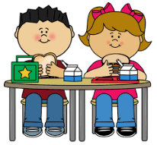
Lunch is an important meal for school going children. It should provide one third of their recommended daily allowance of nutrients without being high in fat, sugar or salt. It should also provide dietary fibre (roughage).
The traditional packed lunch of milk and sandwiches is under attack from a range of convenience foods like crisps, sweets, biscuits, chocolate and soft drinks. Parents and teachers are concerned about this trend, but some find it difficult to come up with popular healthy alternatives. We will ask you to encourage a healthy lunch right from the start. Also, please, only give your child something you feel he/she can easily manage to eat. Children are not normally very hungry at school, so a little snack will do.
A healthy packed lunch should contain bread or an alternative, a savoury filling which provides protein, a suitable drink and some fruit and/or vegetables. Children are allowed to bring one small treat every Friday. Crisps, fizzy drinks and chewing gum are not allowed in school.

Lunch Suggestions:
Bread or rolls (preferably wholemeal)
Rice
Pasta
Wholemeal scones
Lean meat
Tinned Fish e.g. tuna/sardines
Cheese
Fruit & Vegetables (apples, banana, peach, plum, pineapple cubes, mandarins, orange segments, grapes, fruit salad, dried fruit, tomato, cucumber, sweetcorn, coleslaw, celery, carrot sticks.

Drinks
Milk, including low fat
Fruit juices
High juice Squashes, i.e. low sugar content
Homemade soup
Yoghurt

Some Important Areas of Early Learning

Getting Ready for Writing

Making letters on paper is not easy for the small child. They must learn to hold the pencil properly and make regular shapes. Your child will develop the ability to get the hand and eye working together. Hand and finger muscles are only gradually developing at this stage.

Correct pencil grip: Hold the pencil between the thumb and index Finger.
Rest the pencil on the middle finger
(Please ensure that your child holds any other writing tool in the same way e.g. crayons, pens, etc)
You Can Help...

- Use manipulating toys (Jigsaws, Lego, beads to thread etc)
- Use playdough or marla to make his/her own shapes
- Give them colouring books and thick crayons
- Use sheets of paper that he/she can cut up with a safe scissors
- When your child begins to use a pencil make sure that he/she holds it correctly at the start. It will be difficult to change later.
- They may be making block letters at home even before they come to school. This is fine. But when your child starts making lower case letters at school you should try to discontinue the blocks and practise his/her new system whenever he/she feels like it. Don't discourage left-handedness. If that is his/her definite natural inclination, don't attempt to change it.
- Form letters and words using various materials e.g. trace letters on their back and he/she can try to guess what it was, trace in the air, trace with a finger on the table, use a sand pit, chalk boards, play dough, thread etc. Children will see this as a game as opposed to writing everything down on paper.
- Ask your child to explain what a letter looks like e.g Is it a tall letter (b, d, f, h, k, l, t), small letter (a, c, e, i, m, n, o, r, s, u, v, w, x, z), long letter (g, j, p, q, y), Does it have a dot?, Is it curved?, How many times do I need to lift my pencil to write it? e.g letter f has two movements).
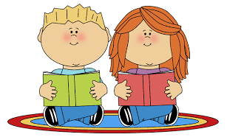
Pre-reading

Ability to read is the foundation for all future progress in our school system. However, learning to read is a gradual process and a lot of preparatory work must be done before a child is introduced to his/her first reader.
We very deliberately do not rush or push children into reading. We get them ready for it over an extended period. Reading is something to be enjoyed. It should never start as a chore for the small child.

You can Help….

- Have attractive colourful books in the home.
- Read him/her a variety of stories. They will get to associate these wonderful tales with books and reading. You must convey to him/her gradually that books are precious things. They must be minded and handled carefully and put away safely.
- Look at the pictures with him/her and talk to him/her about what they say.
- Read nursery rhymes. He/she will learn them off his/her own bat.
- Sing the alphabet song with your child, so that they at least heard of the letters. If he/she knows what each one looks like, or the letters in their name this will help greatly.
- Above all, don't push your child with early reading. You may turn your child against it for evermore.

Developing his/her command of oral language
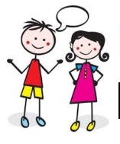
It is important that the child's ability to talk is as advanced as possible. It is through speech that he/she communicates thoughts and feelings, needs and desires, curiosity and wonder. If he/she cannot express these in words he/she will tend to remain silent and will often withdraw from the learning activity of the class. This can be the first sign of failure in the school system and must be remedied, if at all possible. That is why a lot of attention is given to language development in the first years of school.

You Can Help....

- Talk to your child naturally and casually about things of interest that you, he or she may be doing at home, in the shop, in the car, etc. Remember that all the time he is absorbing the language they hear about them. It takes him/her a while to make it his/her own and to use it for his/ her own needs.
- Try to make time to listen when he/she wants to tell you something that is important. But don't always make him/her the centre of attention.
- Answer his/her genuine questions with patience and in an adequate way. Always nurture their sense of curiosity and wonder.
- Introduce him/her gently to the ideas of why? How? When? Where? If? etc. These demand more advanced language structures.
- He/She will have his own favourite stories that he/she never tires of hearing. Repeat them over and over again, and gradually get him/her to tell them to you.
- Ask your child to tell you how they would do something and in what order it is done e.g. making a cup of tea, going shopping, going to bed, changing a nappy…etc.
- Ask questions like, What would you do if….(you got lost in a shop, you saw a statue moving, you found a magic wand? What, Who, When, Where, How, Why?)
- Listen to riddles and nursery rhymes
- Teach him/her some tongue twisters or make up your own e.g. first ask him/her to say three words beginning with f (fish, fighting, Friday), now say them together very quickly or put them into a sentence - (Are fighting fish fun on Friday?). The best tongue twisters have the silliest sentences!!
- Encourage him/her to use words in the right context e.g. a slice of bread, a basket of laundry, and identify and correct mistakes in sentences e.g. I wear a hat on my shoulders.
- Make sentences longer by adding, and, but, because.
In order to be able to read, children need to be fluent at saying the sounds represented by each letter. We use the ‘Jolly Phonics’ Programme to teach the children to read and recognise the 42 different sounds in the series. A lot of time will be spent in class on Phonics activities. In the coming weeks, your child will receive new letters in their ‘Sound Folder’ for homework. When your child is familiar with some of these sounds, they can begin to blend the sounds together to make small words e.g. in, it, an and CVC (consonant, vowel, consonant) words e.g. sit, tin, pan etc.

You can help……

- It is important to hear your child say the name and the sound of these letters and revise previous sounds each day until they are familiar with them all.

- Point out pictures from magazines/ comics that begin with e.g. ‘s’ – ask him/her to think of other words that begin with the same letter - sat, sun, socks etc. This will help him/her to learn the sounds of the letters which will help them with reading.

- Write out some short 3-letter words (CVC words) and sound them out to learn the vowel sounds e.g., sat/ sit/ set, bin/ sin/ win/ tin etc. This will help him/ her to see and hear the association between letters and words.

- Your child can copy any word that you give them onto a scrap piece of paper by sounding out the letters.
- Encourage your child to use the “Look, Say, Cover, Write, Check” method to copy words (Look at the word that you want to copy. Say the word, Cover the word. Write from memory, Check that it is written right)

- He/She may also enjoy doing word games which can be easily made at home.

- Get three boxes and label them 1, 2, and 3.
- Fill one box with common consonants c, d, b, f, h, l, s, g, j, k, m, n, p, r, t, v, w, y, z.
- Fill the second box with vowels a, e, i, o, u.
- Fill the third box with popular ending consonants - b, d, g, m, n, p, r, s, t, w, y.
- Your child can make lots of words by picking one letter from each box and joining them together.

Games like this are great for improving letter recognition, and identifying initial, middle, and final sounds.

Shared Readers
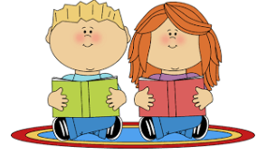
Learning to read is a gradual process and should happen in a relaxed and positive way. The purpose of Shared Reading is to encourage your child to read for pleasure and information (reading to learn as opposed to learning to read). It also ensures that a child is reading at the ability/pace best suited to them.

The first readers that your child will receive in Junior Infants are Oral Language readers. These are picture story books so that your child can use their oral language skills to tell the story. When your child becomes familiar with a variety of common words in class, he/she will receive word books for homework.
During the week your child may get the opportunity in class to talk about the books he/she read at home. Therefore, it is important that this part of homework is completed, and your child will be able to contribute to the class discussion.

Here are some reading tips to remember when your child is ready to begin formal reading in Junior Infants.

- Always allow your child to look at pictures and to talk briefly about them before beginning to read.
- Support your child’s reading by listening attentively
- Ask your child to find particular words on the page, e.g. show me the word “has”, can you find it in another place on the page?
- Ask your child to read a particular words, e.g. what is this word? (when pointing to a word)
- Ask your child to read the whole page.
- If your child needs help with a word just tell them him/her the word and allow the reading to continue. Don’t spend a long time teaching a particular word as school readers are organised in such a way that words are often repeated and become familiar through time. 100% accuracy is not important at this stage. Don’t expect your child to know every word in the book.
- Prompt your child to look for a clue to help them solve the word
- By looking at the picture
- By looking at the letters which make up the word (especially the 1st letter of the word).
- Children who find reading difficult will be extra sensitive to negative comments so please try to give as much encouragement and praise as possible
- Involve yourself in their reading: Read alternate pages, ask each other questions, discuss the story. If your child has read a library book at home, encourage him/her to bring it into school to read it for the class.
- You could also ask him/her retell the story in their own words or change the ending.
- Children enjoy books like “Where’s Wally?” or “Spot the Difference” which are great fun and they also encourage good visual and observation skills
- Continue to read stories to your child regularly and ask them to retell the story in their own words. While you are reading, have them follow the words with their finger. This will help them associate the sound of the word with how it looks.

Class Reader and flashcards (Over The Moon series)

The purpose of using a class reader is to teach children to read for purpose and to teach some common and tricky words. In the coming weeks, teachers will send home words/flashcards from the first book in the Over The Moon Series. Each child will have a copy of the class readers and they will learn new words at their own pace. Practicing reading at home every night is vitally important.

Your child will be learning these 60 Jolly Phonics tricky words in Infants. Most of these words will be learned through sight and not by sounding out the letters. These words are needed to make learning to read easier to grasp.
I | are | go | only | any | could
the | all | no | old | many | should
he | you | so | little | more | would
she | your | my | down | before | right
me | come | one | what | other | two
we | some | by | when | were | four
be | said | like | why | because | goes
was | here | have | where | want | does
to | there | live | who | saw | made
do | they | give | which | put | their

10 Flashcard Games

(Games to play using the letters/letter sounds and words in your child’s homework folder)

- ‘Bingo’: Place the letters/words on a table. Call out a letter/word to your child and they must find the correct card and turn it over. When all the cards are turned over they can do the ‘Victory Dance’!

- ‘Who Am I?’: Place the letters/words on a table. Give clues to your child about your chosen letter/word and they must guess the correct letter/word and turn it over.
eg: I have 3 letters, 1 vowels and 2 consonants. I begin with a ‘t’ sound and the word ‘he’ is hidden inside me
Answer: ‘the’

- ‘Counter Toss’: Place the letters/words on a table - take turns to toss a counter onto a word and say that word. The person who reads the most cards correctly is the winner

- ‘Tic Tac Toe: Place the letters/words on a table. Same the rhyme ‘Tic Tac Toe here I go, where I stop I do not know’ – your child says the word that you stop on and remove the word if they read it correctly.

- ‘Voices’: children read the letters/words aloud but change their voice eg loud, soft, whisper, squeaky voice, growl, baby-talk, giant etc

- ‘Flashlight’: turn off the lights and flash a torch on a letter/word and your child must look and say the letter/word correctly.

Written Activities:

- ‘Beat the Clock’: set a timer and see how many times a letter/word be written in 1 minute. Alternatively, they can write as many letters/words as they can in the allocated time.

- Make ‘Rainbow Words’- Children write their letters/words on scrap paper and then write over the letter/word several times using different colours to create rainbow words.

- Make letters/words using play dough, string, scrabble pieces, stencils, magnetic letters, etc. Alternatively they can trace the letters/words onto sand, sprinkles on a tray etc

- ‘Say it, Make it, Write it’:
- Place a letter/word on the table and ‘Say it’
- Make the letter/word using playdough, individual letters, string etc
- Write the letter/word on paper, sand, blackboard, whiteboard etc

Understanding Maths
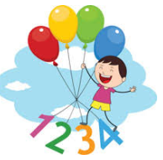

Maths for the small child has nothing to do with "sums" or figures or tables or adding and subtracting. These will all come much later. Maths is really part of the language he uses in understanding and talking about certain things in his daily experience e.g.
He associates certain numbers with particular things — two hands, four wheels, five fingers etc.
- Counting - one, two, three, four, etc.
- Colours - black, white, red, green, etc.
- Prepositions (telling position) and their opposites: over/under, before/after, inside/outside etc.
- Matching/Sorting — objects of the same size/colour/texture/shape etc.
- Odd One Out - difference in size/colour etc.

Understanding of these concepts comes very quickly for some children. For others it takes a long time. Be patient. You cannot force Maths understanding on a child.

You Can Help...
- In the course of your ordinary daily routine in the home, in the shop, in the neighbourhood you should use suitable opportunities to casually introduce the maths vocabulary referred to above. E.g. How many cakes? The glass is full/empty. We turn left at the lights.
- The child gets to understand Maths best by handling and investigating and using real objects. This has been his/her natural method of learning since he/she was a baby. This at times can be time-consuming but it allows him/her to do the learning and the final result is well worth it.

Gaeilge
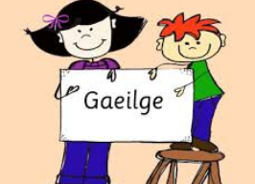
All children enjoy learning another language besides their own language. They have no difficulty in picking it up because it fascinates them as another code of communication.
They are free of any hang-ups about Irish unless they become aware that the home attitude towards it is not good. So please be careful that anything you say does not give a negative attitude to your child.
Give encouragement and help in their efforts to acquire Irish. If they learn new words in school encourage them to use them at home. Use little Irish phrases or words now and again. Children are delighted to find out that their parents are into their new code as well. Let them enjoy it and master it to the best of their ability.

Other Areas of the Curriculum
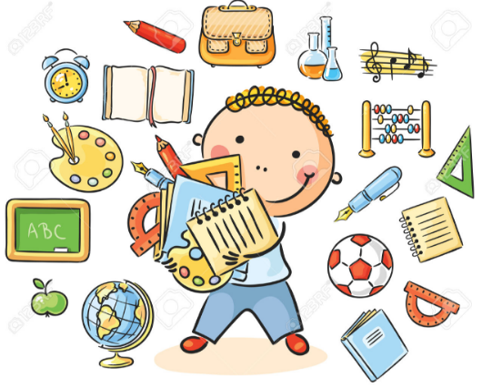
The child in their early years at school learns a lot through many activities. General development is enhanced through Art & Craft, P.E., Music, SESE, SPHE and of course through Religious Education.
Moral and social aspects are covered right through the school day e.g. kindness to others, sharing with them, saying we are sorry, being aware of God through the beauty of nature etc.
The children learn their prayers and bible stories gradually. Again, as in the other areas we referred to already, the child will benefit from practising at home what he/she has learned at school. They can then make their own contribution to the usual family prayers.
Social skills are very important. We encourage good manners at all times, please/thank you, addressing teachers properly, being courteous to fellow students and teachers. It is important to ask your child whom he played with at school and to ensure he isn't alone, also encourage mixing rather than being dependent on one friend only. Rough behaviour is totally discouraged in the playground. You will find a list of school rules and policies in the enclosed School Booklet for Parents.
In your child’s early years at school they will participate in Aistear. This curriculum framework involves physical play, creative play, language play, pretend play and games with rules. It helps build relationships, creativity, language and develops literacy and numeracy skills.

Relationships and Sexuality Education (RSE) is part of Social, Personal and Health Education (SPHE). RSE provides children with structured opportunities to develop the knowledge, attitudes, values, beliefs and practical skills necessary to establish and sustain healthy personal relationships as children and, subsequently, as adults.
The topics covered include:

- This Is Me
- Who Are You?
- We Are Friends
- This Is My Family
- People Who Keep Us About Keeping Safe
- We Have Feelings
- New Life
- I Grow
- Making Choices

The approaches used to teach these lessons may include Stories and Poems, classroom discussion, group work, games, art activities, quiet time, a, visitor to the classroom, videos, educational drama etc. For more information please visit www.pdst.ie/SPHE

The Stay Safe Programme
The Stay Safe programme is a personal safety skills programme for primary schools. The aim of the programme is to reduce vulnerability to child abuse and bullying through the provision of personal safety education for children and training for teachers, school management boards and parents. It is developmentally structured to enable primary school teachers to deliver an abuse prevention education that addresses personal safety issues such as physical, emotional and sexual abuse as well as bullying and stranger danger. The Stay Safe Programme will be taught in alternate years either in Junior Infants or Senior Infants. It is generally taught in Term 3. The topics covered include:

1: Feeling Safe and Unsafe
2: Friendship and Bullying
3: Touches
4: Secrets and Telling
5: Strangers

• About Feelings: To recognise the importance of feelings; how to express them appropriately and in particular to recognise unsafe feelings
• About Friendship: Making and keeping friends and the value of friendship
• About Bullying: What bullying is; strategies for dealing with bullying behaviour, and that it is never acceptable to bully others
• The importance of building confidence and self-esteem
• How to identify and deal with inappropriate or unsafe touch
• That it is ok to say ‘no’ to an adult in a situation where they feel unsafe, threatened or frightened
• To identify trusted adults whom they should tell if they are feeling frightened, threatened, worried or unsafe in any way
• To understand how someone might bribe, trick or threaten them to keep a secret
• It is never their fault if they are victimised or abused
• That they should never go anywhere with or take anything from a stranger
• Appropriate language for telling.
For more information please visit www.pdst.ie/SPHE

Child Protection
The school follows the DES child protection guidelines and has a Child Protection policy with Pauline Clarke as Designated Liaison Person (DLP) and Clare Mc Nally as Deputy Designated Liaison Person (DDLP). All other teachers in Scoil Phádraig are mandated persons. In cases of a disclosure; the DLP will follow the procedures as set out in handbook ‘Child Protection Procedures for Primary and Post-Primary Schools 2017’. Our Child Safeguarding Statement can be viewed on our school website www.scoilphadraigcorduff.ie

School Self Evaluation (SSE)
Scoil Phádraig have been involved in the process of School Self Evaluation (SSE) for a number of years. We will continue to focus on writing genres in literacy. In numeracy we will continue to focus on problem solving and mental maths. We will also concentrate on the New Primary Language Curriculum. The process of SSE has shown improvements in Oral language, reading, writing and problem solving throughout the school. Assessment of learning and for learning is a focus in all classrooms. Assessment methods used include self-assessment, conferencing, portfolio assessment, concept mapping, questioning, teacher observations, teacher designed tasks and tests and standardised tests.
Parting Thoughts
Who is the Boss?
Bit by bit the child will get used to the general discipline of the classroom. He/she will get to understand very quickly that in certain important matters an instruction from the teacher must be obeyed promptly and without question.
Teacher and Parent
At the early stages some parents meet the teacher almost daily and this is a very desirable thing. However, if there is something in particular that you would like to discuss you can arrange to meet her at a time when you both can have a little peace and quiet.

Easy Does It
There are lots of ideas and suggestions in this little book as to how you can help your child. We are not advocating that you do ALL of these with him/her in a systematic way. But if you find from time to time that he/she enjoys a fun approach to certain aspects of learning then we would say give it a go — but remember don't overdo it.

Our Hope
We are offering this Guide to Parents as a little practical help in dealing with the education of their children at the very early stages. We will be very happy if you dip into it from time to time and find something in it of value to you and your child.

"Mol an óige, agus tiocfaidh sí”
