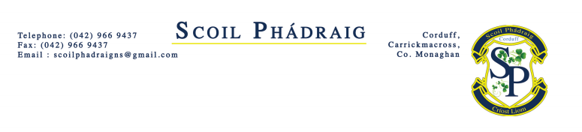
ANNUAL ADMISSION NOTICE
in respect of admissions to the 2023/2024 school year

Admission Policy and Application Form
A copy of the school’s Admission Policy and the Application Form for Admission for 2023/2024 is available as follows: –
To download at: https://www.scoilphadraigcorduff.ie/
On request: By emailing scoilphadraigns@gmail.com or writing to Scoil Phádraig, Corduff, Carrickmacross, Co. Monaghan
PART 1 - Admissions to the 2023/2024 school year
Application and Decision Dates for admission to 2023/2024
The following are the dates applicable for admission to Scoil Phádraig

The school will commence accepting applications for admission on | 10th January 2023
The school shall cease accepting applications for admission on | 31st March 2023
The date by which applicants will be notified of the decision on their application is | 1st May 2023
The period within which applicants must confirm acceptance of an offer of admission is | 15th May 2023

Note: Late applications may be accepted. The school will consider and issue decisions on late applications in accordance with the school’s admission policy.

*Failure to accept an offer within the prescribed period above may result in the offer being withdrawn

The number of places being made available in 2023/2024 is 25.

